Dulles Executive Plaza (DEP) I
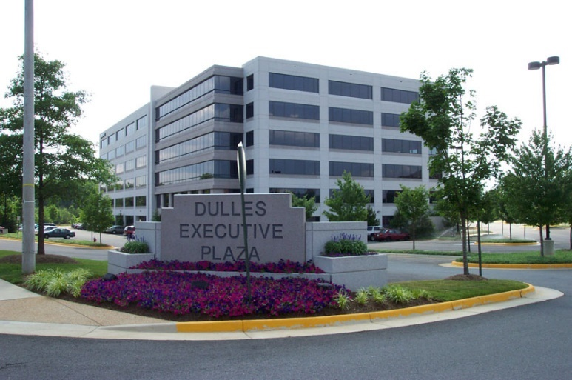

Address
13530 Dulles Technology Dr
Herndon, VA 20171-3414

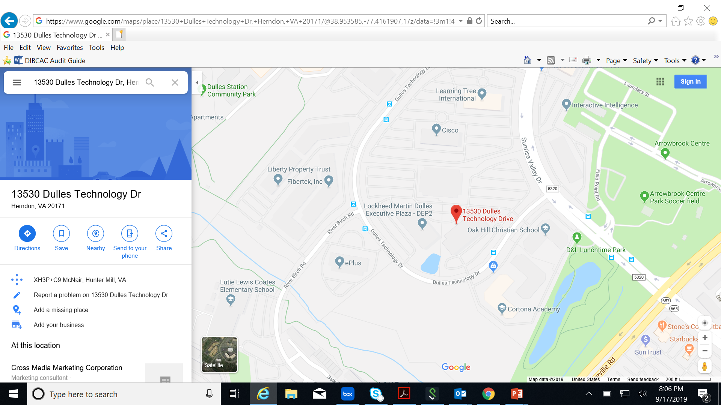

Student Participants and Coaches
From Dulles Technology Drive: Turn into the complex, Dulles Executive Plaza I is the building on the left. You may park in the Lot in front of the building or in the garage.

Dulles Executive Plaza I: Proceed to the lobby and turn right to the Amenity Center , the competition will be held there.

