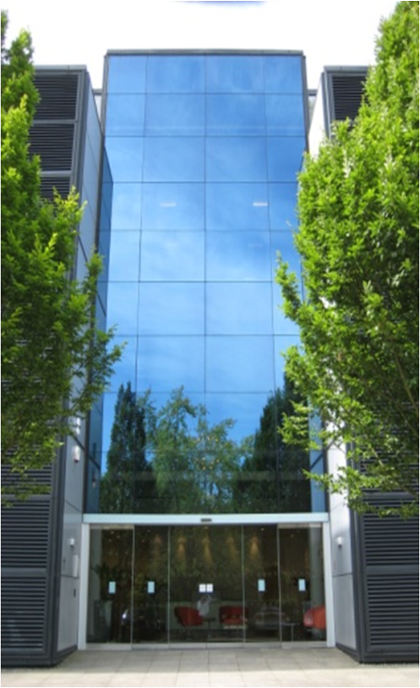
Lockheed Martin UK
IS&GS

FUSION 1

Visitors Safety & Security Guide

Welcome to Lockheed Martin UK IS&GS
We trust that your time with us will be safe

Lockheed Martin UK
IS&GS

FUSION 1

Visitors Safety & Security Guide

Welcome to Lockheed Martin UK IS&GS
We trust that your time with us will be safe

Lockheed Martin UK Ltd

Fusion 1
1000 Parkway
Solent Business Park
Whiteley
Fareham PO15 7AA
Telephone: 02392443333

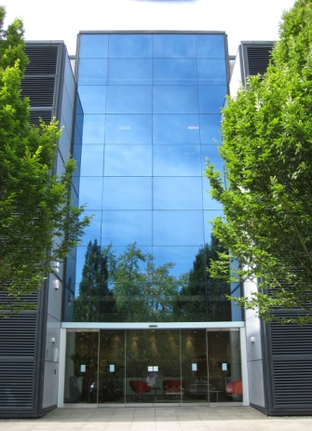

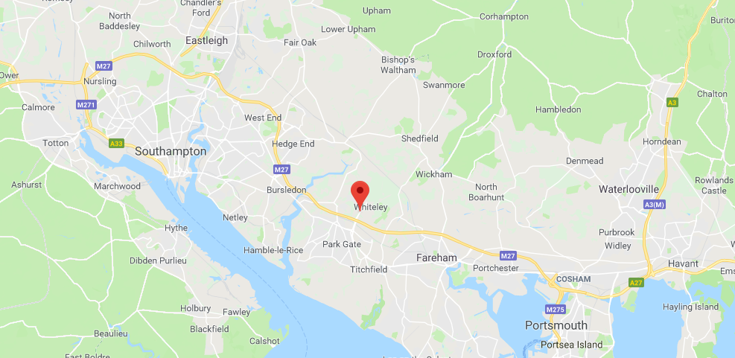

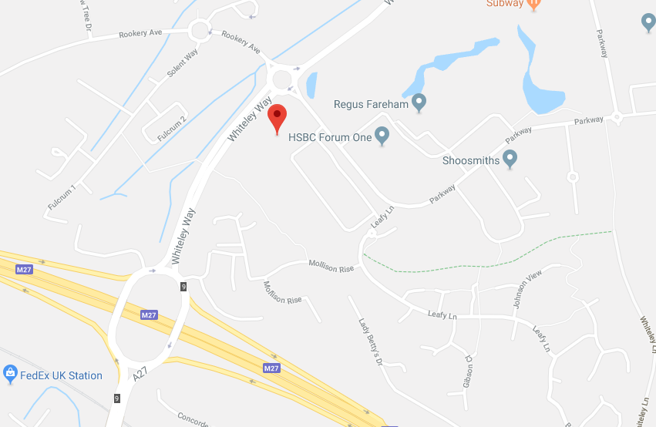

By Road
Fusion 1 is approx. ¼ mile from Junction 9 M27

By Rail
Nearest Stations are Bursledon and Swanwick

Nearest Main Line Station is SOUTHAMPTON PARKWAY
Approx. 8 miles from Fusion 1
Taxis are available from outside the station

VISITORS TO FUSION 1

Parking Restrictions:
There are no parking restriction at Fusion 1 during weekends.

After parking, there will be a member of Lockheed Martin staff to greet you. If this is not the case, please use the buzzer for “Lockheed Martin” located to the left of the glass doors.

EMERGENCY PROCEDURE
Please familiarise yourself with the location of all Fire Exits, and, in particular, the one nearest to where you sit. There will be safety briefing by one of the team at the start of the day.

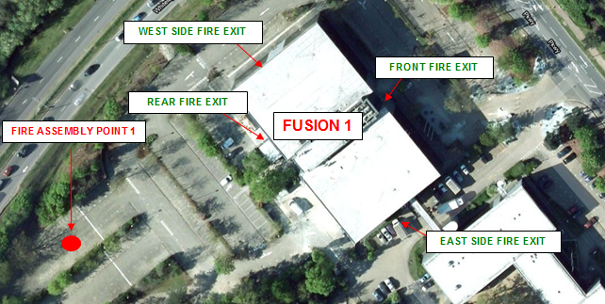

If you discover a FIRE, please raise the alarm by going to your neatest fire alarm call point and activate it immediately by breaking the glass. The Fire Alarm will sound continuously, please make your way to the nearest fire exit. Please remain with your host and follow them to their muster point and await further instructions. Leave quickly but do not run. Do not use the lifts.

MOBILE TECHNOLOGY

For Code Quest, we ask that all mobile phones/tablets/personal devices for both students & coaches are left securely in your vehicles.

If a parent, guardian, next of kin or other needs to contact a student or coach during the competition, we ask that you use the number below where Sophie and/or another volunteer will address the situation accordingly. This number can be provided to relatives is to be used only in the case of an emergency.

Emergency Contact Number: Sophie Williams 07976860771

WI-FI CONNECTION

There will no access to Wi-fi on the day of the event unless instructed by a member of Lockheed Martin.

CAMERAS

Only authorised users are permitted to take images on site. Visitors are not permitted to take images under any circumstance.

USE OF IT SERVICES & EQUIPMENT

For Code Quest, please speak to a member of staff who will be able to assist with your IT set up. There will be instructions on the day of the event and volunteers on hand.

SECURITY
All visitors are required to sign in and out of the visitor’s log which is located on the first floor Lockheed Martin Front Desk.
Please note: All visitors are required to be escorted at all times. Please ensure there is always a member of Lockheed Martin staff with you whilst you on are on site.

ENVIROMENT, SAFETY & HEALTH (ESH)
LMUK is committed to ensuring that employee, visitors and others are protected, so far as is reasonably practicable from risks to health and safety arising from work activities.

Please note: FUSION 1 is a non-smoking site. Smoking is only permitted in designated outside areas. Please ask your host.

LOCAL A&E
Queen Alexandra Hospital
Southwick Hill Road Cosham,
Portsmouth
PO6 3LY

