**Lockheed Martin UK, Whiteley Office**

**Second Floor, Building 3000C**

Solent Business Park,

Whiteley

PO15 7FX

Telephone: 02392 443333

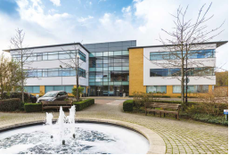

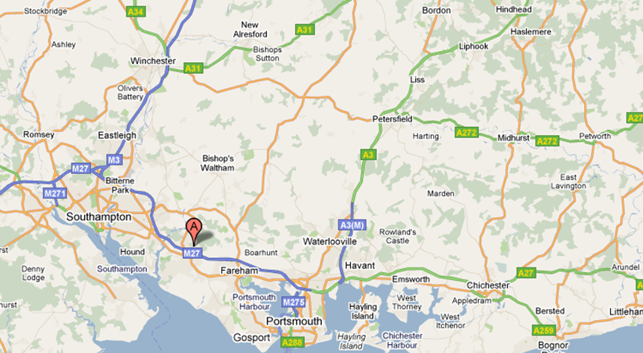

**By Road**

Building 3000C is approx. ¼ mile from Junction 9 M27

**By Rail**

Nearest Stations are Bursledon and Swanwick

**Nearest Main Line Station is SOUTHAMPTON PARKWAY**

Approx. 8 miles from Fusion 1

Taxis are available from outside the station

**VISITORS TO WHITLEY OFFICE**

Please be aware that there are limited parking spaces onsite. A visitor space will be allocated to you (if available) on your visitor booking confirmation. Alternative parking can be found offsite near to the Whitley Office. Please speak to your host about this if you have not been allocated a space.

On arrival at Building 3000C, please park in your allocated Lockheed Martin visitor space identified by a green LHM sign and bay number. Visitor spaces are located to the right as you come through the first car park barrier.

After parking, please report to building 3000C reception where your host will be notified of your arrival and you will be provided with a green visitor parking pass which must be displayed on the dashboard of your vehicle.

If building reception is unmanned, please go to Building B where security is located, and they will notify us of your arrival.

**EMERGENCY PROCEDURE**

**FIRE EVACUATION – Fire Alarm Test is every WEDNESDAY – 09.30AM** - You do not need to react until instructed to by a member of the fire warden team.

Please familiarise yourself with the location of all Fire Exits, specifically, the one nearest to where you sit.



If you discover a FIRE, please raise the alarm by going to your neatest fire alarm call point and activate it immediately by breaking the glass. The Fire Alarm will sound continuously, please make your way to the nearest fire exit or as directed by the Fire Warden. Please remain with your host and follow them to the muster point and await further instructions.

Do not use the lifts, Do not carry drinks, Do not smoke, Do not use mobile telephones

**MOBILE TECHNOLOGY**

Non-LMUK equipment / devices may not be connected to the Lockheed Martin UK (LMUK) LAN.

**WI-FI CONNECTION**

Your host will have to request for a password to access Wi-Fi connection.

**CAMERAS – NO PHOTOGRAPHY SITE**

Only authorised users are permitted to take images on site. Visitors are not permitted to take images unless properly authorised through LMUK Ltd site management and issued with a camera pass.

**USE OF IT SERVICES & EQUIPMENT**

Please do not connect any equipment to our infrastructure without first contacting and getting the assistance of IT Services who can be contacted on 0800 169 0450. Internal shortcut dial *3100

 IT Services can also help you with the transferal of data, preparation of presentation media and other ad hoc IT needs during your visit with us.

Arrangements for these requests are best made through your host and can be made in advance of your visit.

**SECURITY**

All visitors are required to sign in and out of the visitor’s log which is located on the Ground Floor Front Main Reception Desk.

The LMUK Office Admin Team & Ground Floor Reception Hours are:

08:30 – 16:30 (Monday – Friday)

Note: You will need an LM host to enable you to get in/out of the building after the office admin area is closed.

Please ensure your visitor badge is visible at all times. Your badge will not permit access through controlled doors. Badges must be returned daily in the badge drop box in the ground floor reception area (unless otherwise agreed).

**ENVIROMENT, SAFETY & HEALTH (ESH)**

LMUK is committed to ensuring that employee, visitors and others are protected, so far as is reasonably practicable from risks to health and safety arising from work activities.

Please note: 3000C is on a non-smoking site. Smoking is only permitted in designated outside area located between Buildings 3000A & 3000B. Please ask your host for details.