Lockheed Martin Canada RMS
Presents

April 27, 2019

A STEM initiative
STEM Event – Code Quest, Saturday, April 27, 2019
Hosted at: LM Canada RMS, 40 Highfield Park Dr., Dartmouth, NS

School Briefing:
Personal Security at LM Canada Facilities

- Non-Lockheed-Martin devices capable of audio/visual recording or transmission (cameras, cell phones, tape recorders, PDAs etc.), are restricted in LM Canada MST facilities unless authorized by the LM Security Department (participants of this event are not authorized).

Cell phones are NOT permitted – cell phones must be left at home or with front-desk security

- Non-Lockheed-Martin firearms, ammunition, explosives and flammable material are prohibited from LM Canada MST facilities, including parking areas and surrounding property.

- Upon arrival, there is a mandatory check in at reception – visitors must show ID and sign a Visitor form.

- Attendees will be briefed on Confidentiality Requirements before entering Restricted Areas.

Health and Safety Awareness

- Attendees will be briefed on Site Facilities and Evacuation processes upon arrival.

- The LM facility is a scent-free environment – please refrain from wearing perfumes and cologne.

- Please communicate any allergies, including dietary considerations, in advance of the event date so that they may be accommodated – lunch will be provided.

- Please be assured that there is no radiation risk on the date of the event -- only unclassified simulations will be run.

- No open-toe shoes, shorts, or mini-skirts will be allowed for health and safety reasons.

Schedule:

8:00am Students arrive at Lockheed Martin Canada, 40 Highfield Park Drive, Dartmouth NS
- Photo IDs presented
- All Cell Phones secured

8:15-8:30am Students get team photos by LM Logo and then head into Code Quest Zone
- Pass in pre-signed Visitor, Security and Safety Briefing
- Find team station in RM 142

8:30-8:45am Test Station
- Login to computer
- Run example problem to ensure connectivity

8:45-9:00am Breakfast Cafeteria
- Buffet of food, coffee, tea, juice and water

9:00 – 9:15am Senior LM Personnel Welcomes Youth to site

9:15-9:25am MC gets youth energized – reminder of RULES

9:30-11:30am CODE QUEST

9:30-10:30am Coach’s Corner tour of Building and provide demos in TCC – Shift 1
- 3D printing
- Coding 101
- STEM Bots
10:30 – 11:30am Coach’s Corner tour of Building and provide demos in TCC – Shift 2
- 3D printing
- Coding 101
- STEM Bots

11:30-1:00pm – LUNCH in Cafeteria
- Pizzas and assorted beverages and cookies

12:00-1:00pm – Judges deliberate

1:00-2:00pm – Awards presented, closing remarks and Swag handed out

- Highfield Park Drive via car from Hwy -

- From Hwy of Heroes (Dartmouth)
- Take exit 3 for Highfield Park Drive
- Turn left onto Burnside Drive
- Continue on Highfield Park Drive
- Destination is on the right

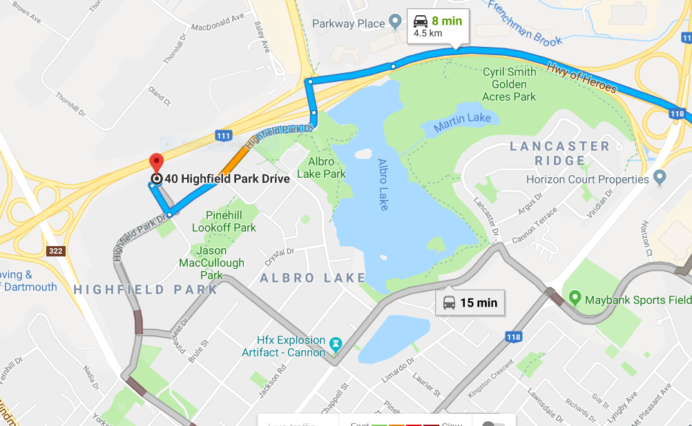
Arrival at 40 Highfield Park Drive via Bus -

Directions from Highfield Park Drive Bus Terminal:
- From Transit Terminal walk North (towards Burnside Drive) along Highfield Park Drive
- Destination is on your left

Visitor Responsibilities:
1. Before arriving on site, please have each attendee sign off on the Visitor Briefing – Conditions of Access form and Photo Release form and bring with them to the event
2. Please communicate any known food allergies to Stacey Parks by phone at 902-468-3399 x5193 or via email at stacey.parks@lmco.com; we can accommodate alternate breakfast and lunch plans where needed.
VISITOR BRIEFING – CONDITIONS OF ACCESS
As a visitor requesting access to Lockheed Martin Canada facilities, you are requested to read and sign the following “Conditions of Access”. Your signature indicates your willingness to comply with the following security and safety requirements as a condition of access.

1. Advise the receptionist if you have in your possession any of the following restricted items. The receptionist will retain these items:

- Cameras and/or video recording devices;
- Audio recording devices;
- Laptop computers;
- Any equipment capable of visual, electronic or wireless recording or transmission; and/or
- Non-LM Canada employee or visitor telephones or pagers.

2. The following items are strictly prohibited from entry onto or into Lockheed Martin property or facilities:

- Firearms (except for peace officers);
- Ammunition (except for peace officers);
- Flammables (for personal use); and/or
- Explosive material.

3. Ensure that your Lockheed Martin badge is clearly visible at all times.

4. Remain with your sponsor at all times.

5. Do not enter any area where you do not have a “Need-to-Access” for the completion of your visit requirements.

6. Upon your departure, return your Visitor Badge and retrieve any items left at the reception desk.

7. In the event of a facility emergency, promptly depart the building with your host upon activation of the fire alarm system.

8. Comply with requests of the Security Staff.

Name (Print):

Signature: Date:

Company:

