Lockheed Martin Canada RMS
Presents

May 2nd 2020

A STEM initiative
STEM Event – Code Quest, Saturday, May 2nd 2020
Hosted at: LM Canada RMS, 40 Highfield Park Dr., Dartmouth, NS

School Briefing:
Personal Security at LM Canada Facilities
- Non-Lockheed-Martin devices capable of audio/visual recording or transmission (cameras, cell phones, tape recorders, PDAs etc.), are restricted in LM Canada MST facilities unless authorized by the LM Security Department (participants of this event are not authorized).

- Cell phones are NOT permitted – cell phones must be left at home or with front-desk security

- Non-Lockheed-Martin firearms, ammunition, explosives and flammable material are prohibited from LM Canada MST facilities, including parking areas and surrounding property.

- Upon arrival, there is a mandatory check in at reception – visitors must show ID and sign a Visitor form. A government issued photo I.D. will be required for anyone over 18. School IDs are acceptable for students under 18.

- Attendees will be briefed on Confidentiality Requirements before entering Restricted Areas.

Equipment
- Each team is allowed to bring one computer to the competition unless otherwise stated on the location-specific pages. No virtual machines, etc. are allowed.
- Printers are not allowed.
- Monitors are not allowed.
- No pre-written code is permitted.
- Thumb drives are not allowed.
- Compatible device: Windows (Windows 7 or later), Macintosh (Snow Leopard or Later), or Linux.
- Network capable: Any WiFi device which uses 802.11 b/g/n 2.4 Ghz and 5 Ghz.
- Cell phones and broadband network cards are NOT allowed during the Code Quest competition. If you are observed using either, your team is subject to immediate disqualification.

Competition Rules/Guidelines
- The judges' rulings are final.
- The judges will use different data sets to test your programs.
- File naming conventions for solutions must be followed.
- Your team will have a number of programming tasks to choose from. You may not be able to solve them all, so you are advised to study them and choose your problems wisely.
- There is no limit to the number of submissions you can make to solve a problem. However, one of the tie breakers takes incorrect submissions into account.
- Code Quest utilizes a custom client-server submission/judging/scoring system via an 802.11x wireless network. Please ensure your computer is wireless-capable before the event day. If you can connect to a public wireless network (e.g. the public library or Panera) and browse the Internet, you should be in good shape. Some school computers have security lockdowns that prevent wireless configuration, so please verify this before you come. If any PC’s are locked down by the school, we cannot help with that.
- Verify your program works with the example input before submitting it to the judges.

Health and Safety Awareness
- Attendees will be briefed on Site Facilities and Evacuation processes upon arrival.

- The LM facility is a scent-free environment – please refrain from wearing perfumes and cologne.

- Please communicate any allergies, including dietary considerations, in advance of the event date so that they may be accommodated – lunch will be provided.

- Please be assured that there is no radiation risk on the date of the event -- only unclassified simulations will be run.

- No open-toe shoes, shorts, or mini-skirts will be allowed for health and safety reasons.

Schedule:

8:30am Students arrive at Lockheed Martin Canada, 40 Highfield Park Drive, Dartmouth NS
- Photo IDs presented
- All Cell Phones secured
8:30-8:45 Students get team photos by LM Logo and then head into Code Quest Zone
- Pass in pre-signed Visitor, Security and Safety Briefing
- Find team station in RM 142

8:45-9:00 Test Station
- Login to computer
- Run example problem to ensure connectivity

9:00-10:00 Breakfast Cafeteria
- Buffet of food, coffee, tea, juice and water

10:00 – 10:15 Senior LM Personnel Welcomes Youth to site

10:15-10:25 MC gets youth energized – reminder of RULES

10:30 CODE QUEST Competition Begins

10:30am-11:45am Coach’s Corner tour of Building and provide demos in TCC – Shift 1
- 3D printing
- Coding 101
- STEM Bots

11:45 – 1:00pm Coach’s Corner tour of Building and provide demos in TCC – Shift 2
- 3D printing
- Coding 101
- STEM Bots

1:00pm Competition ends, LUNCH begins in Cafeteria
- Pizzas and assorted beverages and cookies
- Judges deliberate

1:30pm Awards presented, closing remarks and Swag handed out

- Highfield Park Drive via car from Hwy -

- From Hwy of Heroes (Dartmouth)
- Take exit 3 for Highfield Park Drive
- Turn left onto Burnside Drive
- Continue on Highfield Park Drive
- Destination is on the right

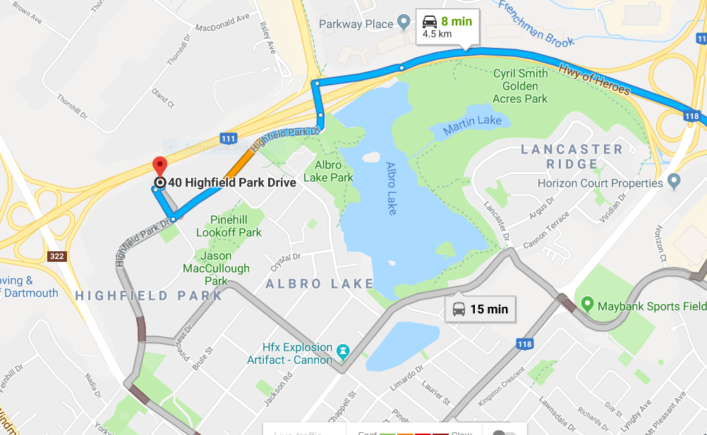
Arrival at 40 Highfield Park Drive via Bus -

Directions from Highfield Park Drive Bus Terminal:
- From Transit Terminal walk North (towards Burnside Drive) along Highfield Park Drive
- Destination is on your left

Visitor Responsibilities:
1. Before arriving on site, please have each attendee sign off on the “Visitor Briefing – Conditions of Access form” and “Photo Release” form and bring with them to the event
2. Please communicate any known food allergies to Victoria Stone by phone at 902-468-3399 x5089 or via email at victoria.l.stone@lmco.com; we can accommodate alternate breakfast and lunch plans where needed.
VISITOR BRIEFING – CONDITIONS OF ACCESS
As a visitor requesting access to Lockheed Martin Canada facilities, you are requested to read and sign the following “Conditions of Access”. Your signature indicates your willingness to comply with the following security and safety requirements as a condition of access.

1. Advise the receptionist if you have in your possession any of the following restricted items. The receptionist will retain these items:

- Cameras and/or video recording devices;
- Audio recording devices;
- Laptop computers;
- Any equipment capable of visual, electronic or wireless recording or transmission; and/or
- Non-LM Canada employee or visitor telephones or pagers.

2. The following items are strictly prohibited from entry onto or into Lockheed Martin property or facilities:

- Firearms (except for peace officers);
- Ammunition (except for peace officers);
- Flammables (for personal use); and/or
- Explosive material.

3. Ensure that your Lockheed Martin badge is clearly visible at all times.

4. Remain with your sponsor at all times.

5. Do not enter any area where you do not have a “Need-to-Access” for the completion of your visit requirements.

6. Upon your departure, return your Visitor Badge and retrieve any items left at the reception desk.

7. In the event of a facility emergency, promptly depart the building with your host upon activation of the fire alarm system.

8. Comply with requests of the Security Staff.

Name (Print):

Signature: Date:

Company:

