What is Code Quest?
Each year, Lockheed Martin hosts Code Quest, an annual computer programming competition where teams of two to three high school students work together to solve problems by using JAVA, Python, C#, and/or C++ programming to complete the “quest”. The problem set consists of 20 to 30 challenging problems created by Lockheed Martin engineers and computer programmers.
Annapolis Junction, MD
Visitor’s Guide
This year’s Code Quest event will take place on April 22, 2023, onsite at Lockheed Martin facilities! Planning is underway to ensure that all necessary precautions with regards to COVID-19 can be observed during this event; most particularly, this means that space will be limited at these on-site events, and registration waitlists will not be available. However, virtual options will remain to ensure everyone has a chance to participate.
We look forward to your participation this year. If you have any questions or concerns, please contact us by email at code-quest.gr-aero@lmco.com
Citizenship Guidelines for Participants
We encourage participation and because we are a contracting company to the United States government, students and coaches will need to show proof of citizenship. Please see guidelines below:
- Participating students must be U.S. Citizens.
- Coaches must be U.S. Citizens.
- Students and Coaches are required to bring proof of citizenship (birth certificate or passport) to the competition. No exceptions can be made.
- Without documentation of citizenship, entry will be denied.

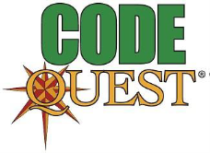
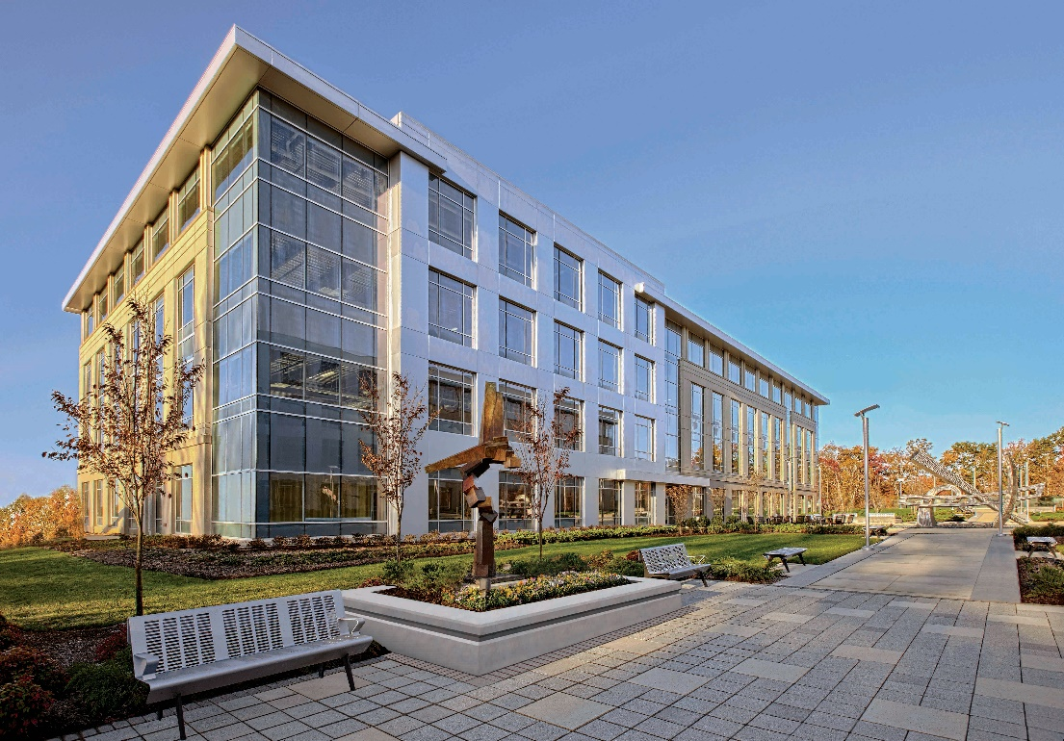
ANJ 6
410 National Business Parkway
Annapolis Junction, MD 20701
410-379-2118
http://www.lockheedmartin.com/us/rms.html

Directions from Baltimore Washington International Thurgood Marshall Airport
Baltimore Washington Marshall Airport is only 12 miles from Lockheed Martin’s Annapolis Junction location. There are several resources available to assist with your transportation to or from the airport and its surrounding hotels / amenities. An extremely useful resource is “BWI MAPS”, with information about locations inside and outside. https://www.bwiairport.com/at-bwi/maps.
From BWI Marshall Airport:
Exiting the Parking or Passenger Pickup Area, continue to I-195 W. Take MD-295 S to MD-175 E in Jessup. Take the MD-175 E exit from MD-295 S. Get on Baltimore-Washington Pkwy. Take MD-175 W/Jessup Rd to National Business Pkwy (NBP) in Jessup. Turn left onto National Business Pkwy; take the 2nd exit from the roundabout onto NBP. 410 will be on the right side of the road. There is extensive parking at the facility. You may also inquire at your lodging location if they have shuttle service to the Code Quest site.
From Baltimore (North):
- VIA I-95 S: Take Light St and E Conway St to I-395 S. From 395 S, take I-95 S to MD-175 E in Columbia. Take exit 41A-41B from I-95 S and continue on MD-175 E. Drive to National Business Pkwy in Jessup.
- VIA 295 S: Take E Lombard St and Russell St to MD-295 S and Follow MD-295 S to MD-175 E in Jessup. Take the MD-175 E exit from MD-295 S. Get on Baltimore-Washington Pkwy; take 175 W/Jessup Rd to National Business Pkwy in Jessup.
- VIA I-95 S and MD-295 S: Take Light St and E Conway St to I-395 S. Take I-95 S, I-195 E and MD-295 S to MD-175 E in Jessup. Take the MD-175 E exit from MD-295 S. Get on Baltimore-Washington Pkwy. Take MD-175 W/Jessup Rd to National Business Pkwy in Jessup.
From Washington D.C. / Virginia (South):
- VIA I-95 N: Get on Baltimore-Washington Pkwy in Bladensburg from New York Ave NW. Follow Baltimore-Washington Pkwy and I-495 N/I-95 N to MD-175 E in Savage. Take exit 41A-41B from I-95 and continue on MD-175 E. Drive to National Business Pkwy in Jessup.
- VIA MD-295 Baltimore Washington Pkwy: Get on Baltimore-Washington Pkwy in Bladensburg from New York Ave NW. Follow Baltimore-Washington Pkwy to MD-175 W/Jessup Rd in Hanover. Take the MD-175 W exit from Baltimore-Washington Pkwy. Follow MD-175 W/Jessup Rd to National Business Pkwy in Jessup.
Local Area Map

