
Supplier Instructions
EDSS Standard Operation Instruction Manual

Supplier Instructions Version 2.0
Reference Only

Table of Contents
Accessing EDSS 2
Initiating a Supplier Workflow 4
Supplier Submittal Form - Field Definition 5
Add A Single Document (or skip to step 11) 8
Add Multiple Documents 9
Adding A Buyer (None In Directory) 12
Adding A Buyer (Already Have Buyers In List) 15
Add Buyers via Buyer Listing Report 17
Delete Buyers via Buyer Listing Report 20
Workflow Submission APPROVED by Lockheed Martin Inspector 22
Workflow Submission REJECTED by Lockheed Martin Inspector 23
Accessing Rejected Submissions My Assignments 24
Accessing Rejected Submissions Communal Mailbox Assignments 27
My (Work In Process) WIP Queue 30
Supplemental Folders - Viewing Information 32
Supplemental Folders – Viewing Detail Information 34
Searching EDSS 37
AccessLM Registration Video 43
Complete AccessLM Registration Video 43

Accessing EDSS
Follow the steps below to access the EDSS main screen:
1. Go to the AccessLM website: https://access.lockheedmartin.com
2. Click Credential Management menu (top of page).
3. Select the Setup 2FA Credentials link.

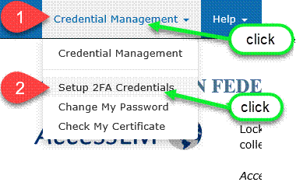

4. Login to the website using an AccessLM (EAD) account by entering the userid and password for the account.
5. Select Sign On.
6. Verify the authenticators available to the user based on their product assignments.
Important: Users will only be presented options that are available to them. Authenticator types not available to users will not show up in the table nor in the authenticator selector screen. If the user does not see Duo listed for any of their products, STOP. The user cannot activate a Duo account and must make a different selection. See KBA00036579-INT.

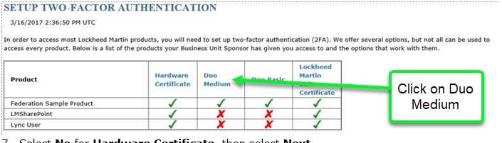

7. Select No for Hardware Certificate, then select Next.
8. Select one of the options for Duo Authentication and select Yes, then select Next.
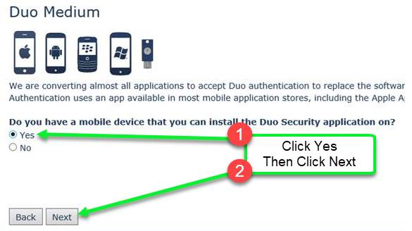
9. Enter the e-mail address associated with the AccessLM account and select Request a Single-use 2FA Registration PIN.
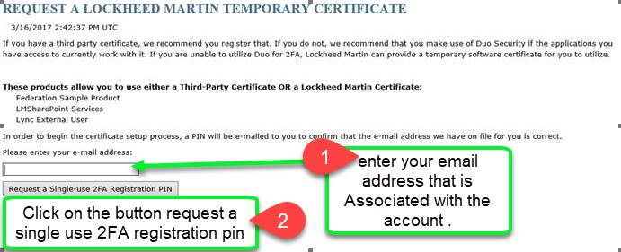

10. Wait for the e-mail you will receive from Registration, AccessLM mailbox with the PIN information. Click the link listed in the email to return to the AccessLM Website.
Note: If the link in the email is disabled, then Copy the link and Paste the link in a browser window.

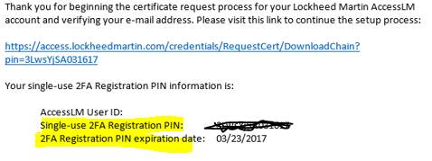

11. Select Start Setup.

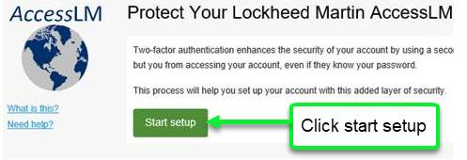

12. Select the authenticator type and select Continue.
Note: Duo Medium only supports a Smart Phone, Tablet, or U2F Hardware Token.

Smart Phone:
- Select Mobile phone.
- Select the country and type in the phone number of the phone.
- Check the box to verify the entered number is correct.
- Select Continue.
- Select the type of Smart Phone and select Continue.
- Install DUO Mobile onto the phone, then select I have Duo Mobile installed.
- Follow the on-screen instructions to add the account to the Duo Mobile app.

Tablet:
- Select Tablet OS and select Continue.
- Install DUO Mobile onto the tablet, then select I have Duo Mobile installed.
- Follow the on-screen instructions to add the account to the Duo Mobile app.
Cell Phone: Duo Basic
- Select Landline and select Continue.
- Select the country and type in the phone number of the phone.
- Enter an extension if one is required.
Check the box to verify the entered number is correct.

You will then be taken to the main EDSS Page.
(Items that appear on the initial screen may differ depending on user permissions)
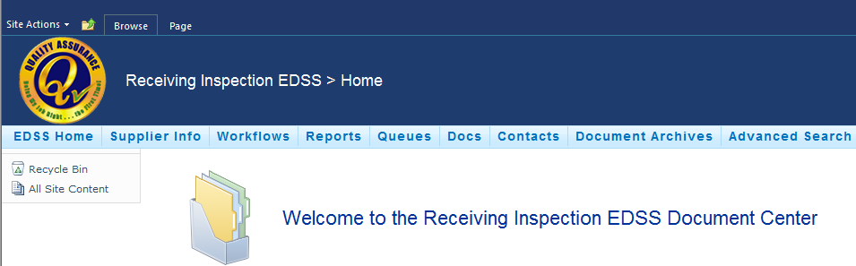

Initiating a Supplier Workflow
Follow the steps below to initiate a supplier workflow:
- Access EDSS by using the URL below:

https://space-us.external.lmco.com/sites/edss/default.aspx

You should see a home screen to the one below:
(Items that appear on the initial screen may differ depending on user permissions)
- Click on Workflows to enable the drop down list and click Supplier Submittal Workflow.
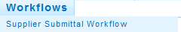
Supplier Submittal Workflow
Company Name, Cage Code, and LM Code should auto populate.
A screen similar to the one below will appear:
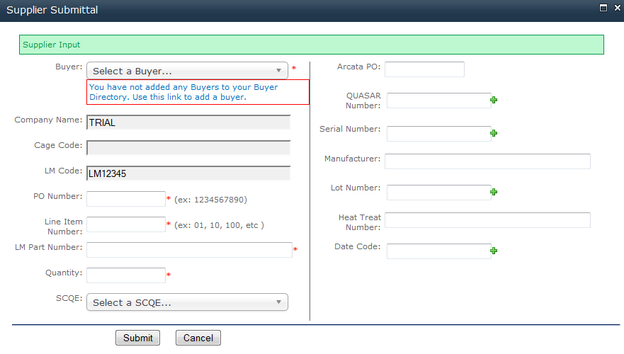
The following tables describe the Fields in the Supplier Submittal screen:

Supplier Submittal Form - Field Definition
Field | Description
Buyer* | Drop down list of buyer you have added, if you haven’t added any buyers a message will appear requesting you do so. See the Adding A Buyer Section for exact steps.  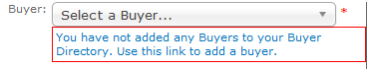
Company Name | Name of the supplier company [cannot be edited]
Cage Code | Cage code of the supplier company [cannot be edited]
LM Code | LM code of the supplier company [cannot be edited]
PO Number* | Alpha numeric field that must be 10 characters in length and will NOT allow spaces or special characters 0000000000
Line Item Number* | A numeric only field used to enter the PO Line Item number. One digit numbers will see a 0 appear in front, for example a 1 will appear as 01.
LM Part Number* | Alpha numeric field used for entering the equivalent LM Part number
Quantity* | A numeric only field containing the quantity of the item(s)
SCQE | Select the SCQE from the drop down list box.
Arcata PO | Alpha numeric field that must be 10 characters in length and will NOT allow spaces or special characters 0000000000
QUASAR Number | Alpha numeric field will NOT allow spaces or special characters
Serial Number | Alpha numeric field will NOT allow spaces or special characters
Manufacturer | Alpha numeric field will accept all entries including spaces and special characters
Lot Number | Alpha numeric field will accept all entries including spaces and special characters
Heat Treat Number | Alpha numeric field will accept all entries including spaces and special characters
Date Code | Alpha numeric field will NOT allow spaces or commas but allow special characters
Notes:
- Fields marked with * are required and will not allow for submission until completed.
- Fields displaying indicate you can have multiple additions, such as multiple Batch, Serial Number, etc.
- If you try to submit a workflow and a field with * isn’t filled out correctly or missing you will see an error.

Below is an example of errors that can be seen.
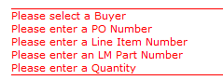

- Enter the appropriate information in the fields.

The Add Attachments screen will appear:
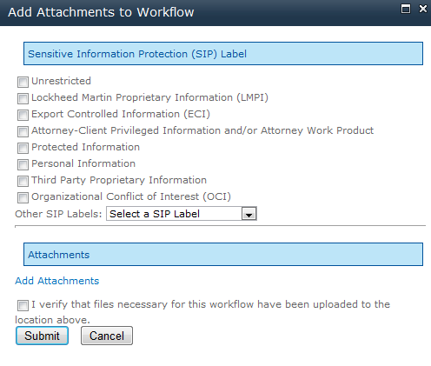
Sensitive Information Protection Label (SIP)
- Choose the appropriate SIP label for the document (s) to be uploaded.

- Click Add Attachments in the middle of the screen.
Add Attachments button
You may see a new browser window appear or a new tab depending on the Browser Brand and version you are using.

New Browser Window
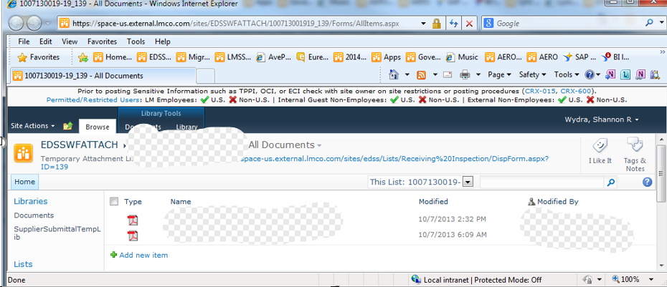
New Browser Tab
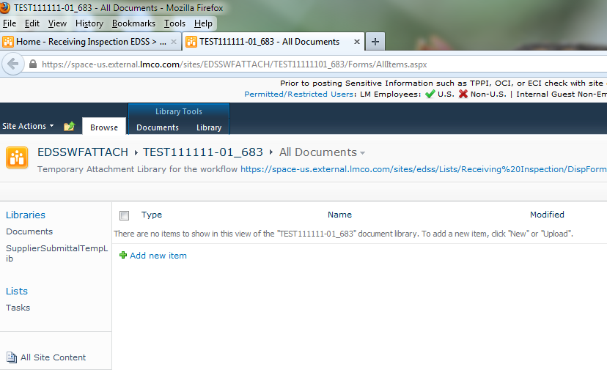
New Tab for Attachments
- Click the Add New Item link
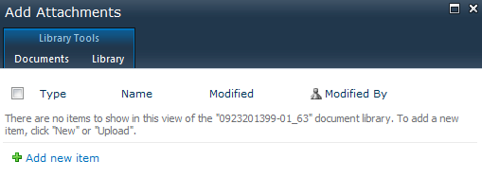
Add New Item

The screen below will appear:
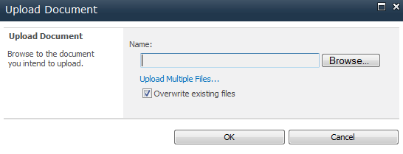
- Choose to Add A Single Document or Choose Upload Multiple Files:

Add a Single Document (or skip to step 11)
- Special characters are not allowed in the name of the document. Below is a list of special characters.

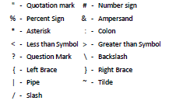

- Click the Browse button

The dialog box below will appear allowing you to navigate to your document and choose Open.

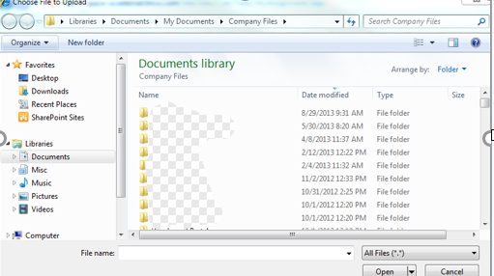
You should return to the screen below.
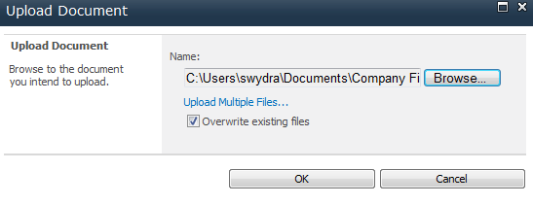
- Click OK and the document will be loaded.

Add Multiple Documents
It should be noted that only users of Internet Explorer can use this capability.

- Special characters are not allowed in the name of the document. Below is a list of special characters.

- Click the link Upload Multiple files in the Upload Document screen.
Upload Multiple Files
You will see a screen similar to the one below appear:
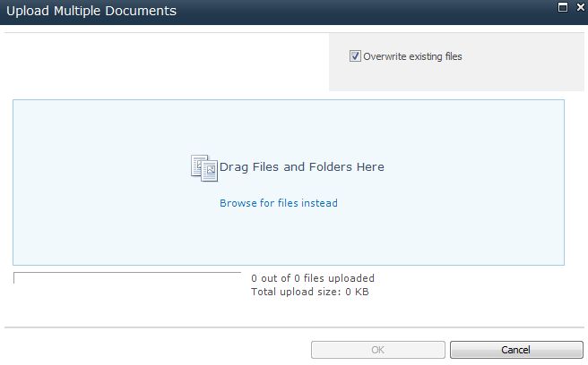
- You can drag and drop files from your desktop or from a folder on your computer using Windows Explorer into the location specified on the screen.

As you drag and drop files they will appear in the window:

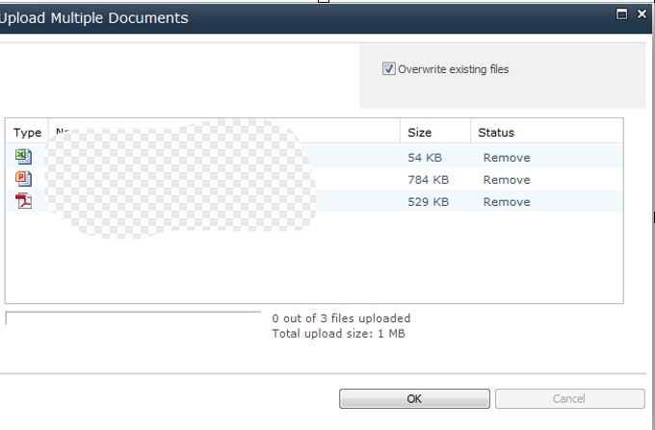
- Click OK and the files will begin to upload.

- Click Done once the files are uploaded.

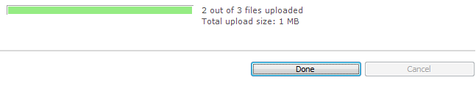

- Click the Close button on the Add Attachments window (look at the options for a Window or Tab).

Closing Attachments In A New Browser Window
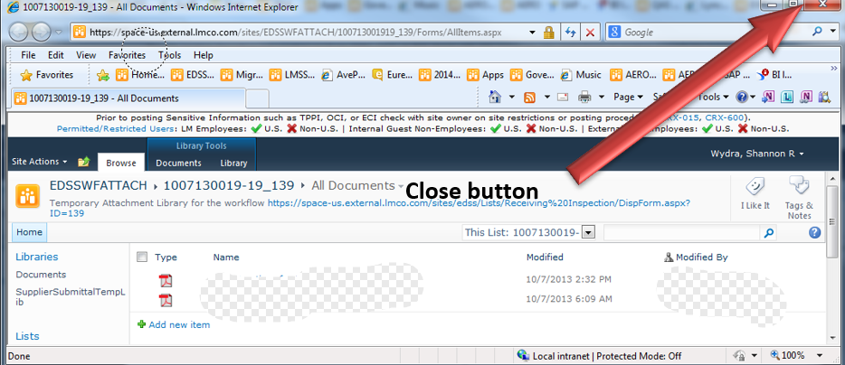

Closing Attachments In A New Tab.

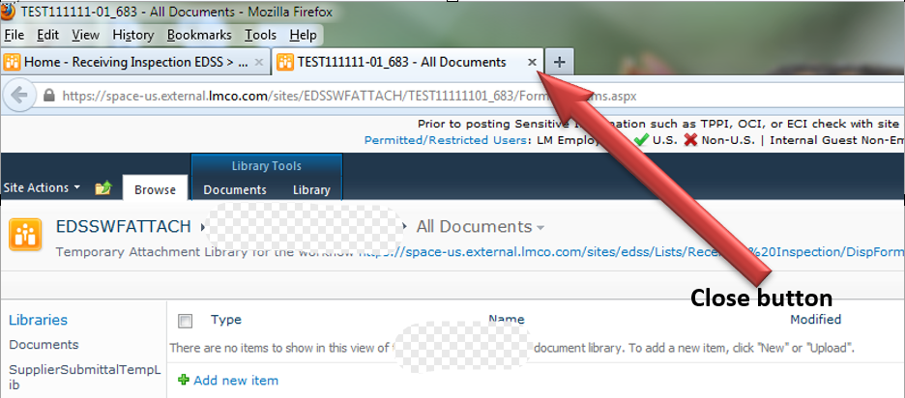
- Check the box I verify that the files necessary for this Workflow have been uploaded to the location above.

- Click on the button.

The workflow will be submitted.

Adding A Buyer (None In Directory)
Buyers will need to be added to the buyer directory in order to be selected on the supplier submittal form. The message below appears when you do not have any buyers listed.
Follow the steps below to add a buyer to the directory for the first time:
- Click on the Blue Words that appear in the message:
The following screen will appear:
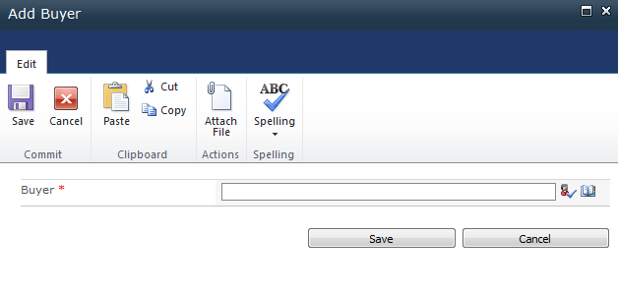

- Choose one of the following methods for entering the buyer name into the Buyer text box:
- Check Names Button - Type the name and click on Check Names to validate
- Address Book - click the Address Book button to open Select People and Groups dialog
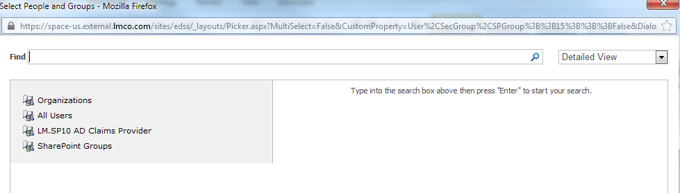
- Type the name in the Find text box and click the
The results will appear:
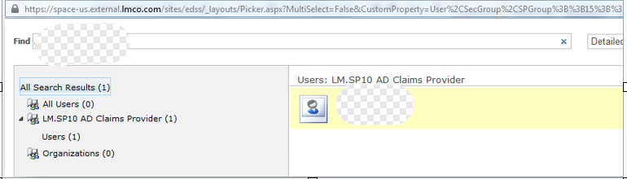
- Click the name and choose OK.
The email address of the Buyer will appear in the Buyer text box: 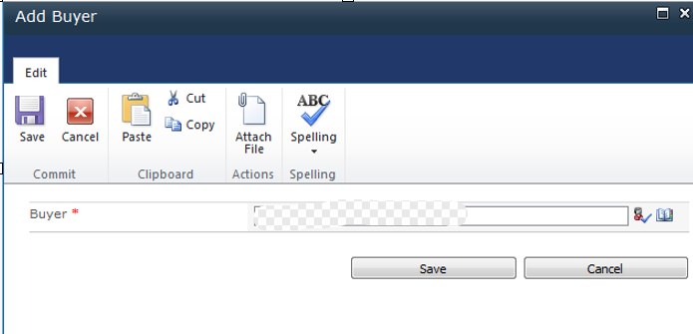
- Click Save.
You will be returned to the Supplier Submittal Form.
The Buyer Section now appears with the following:
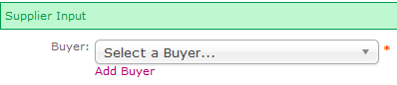
The buyer should now be seen in the drop down list.
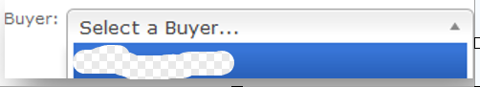

Adding A Buyer (Already Have Buyers In List)
Even if you have buyers that can be selected from the drop down list there may be a time when you need to add a new buyer.
Follow the steps below to add a new buyer:
- Click the Link under the Buyer drop down list box that says Add Buyer:
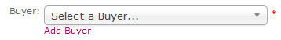
The following screen will appear:
- Choose one of the following methods for entering the buyer name into the Buyer text box:
- Check Names Button - Type the name and click on Check Names to validate
- Address Book - click the Address Book button to open Select People and Groups dialog
- Type the name in the Find text box and click the
The results will appear:
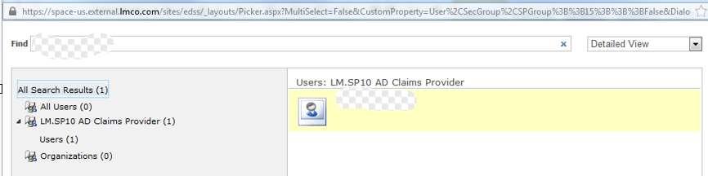
- Click the name and choose OK.
The email address of the Buyer will appear in the Buyer text box: 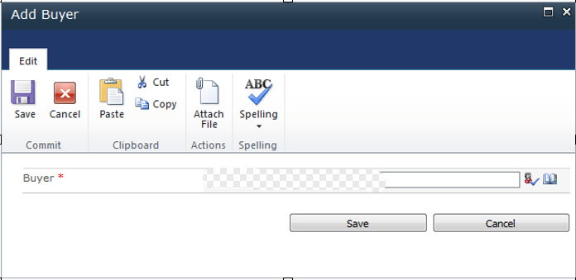
- Click Save.
You will be returned to the Supplier Submittal Form.
The buyer should now be seen in the drop down list.
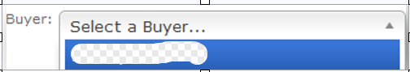

Add Buyers via Buyer Listing Report
You can manage the buyers for your company in just a few easy steps even when you are not uploading a data package.
Follow the steps below to Add Buyers using the Buyer Listing Report:
- Choose one of the following:
- Using your browser access the link https://space-us.external.lmco.com/sites/edss/default.aspx

You will then be taken to the main EDSS Page.
(Items that appear on the initial screen may differ depending on user permissions)
- Click Reports in the menu and choose Buyer Listing.
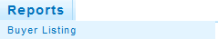
Buyer Listing Report
A screen similar to the one below will appear:
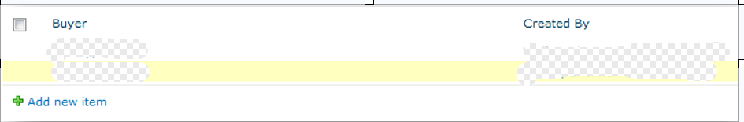
- Click the Add New item link just below the list of Buyers.

The following screen will appear:
- Choose one of the following methods for entering the buyer name into the Buyer text box:
- Check Names Button - Type the name and click on Check Names to validate
- Address Book - click the Address Book button to open Select People and Groups dialog
- Type the name in the Find text box and click the
The results will appear:
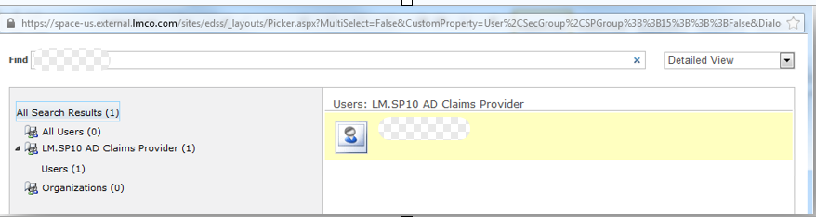
- Click the name and choose OK.
The email address of the Buyer will appear in the Buyer text box: 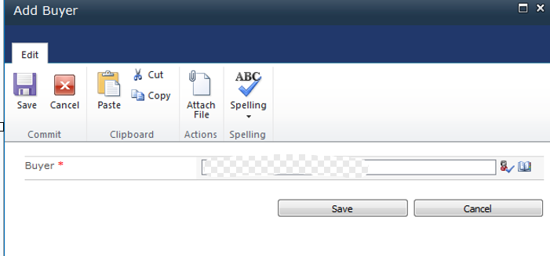
- Click Save.

Delete Buyers via Buyer Listing Report
You can manage the buyers for your company in just a few easy steps even when you are not uploading a data package.
Follow the steps below to Delete Buyers using the Buyer Listing Report:
- Choose one of the following:
- Using your browser access the link https://space-us.external.lmco.com/sites/edss/default.aspx

You will then be taken to the main EDSS Page.
(Items that appear on the initial screen may differ depending on user permissions)
- Click Reports in the menu and choose Buyer Listing.
Buyer Listing Report
A screen similar to the one below will appear:
- Check the box next to the name of the supplier you want to delete.
- Choose Delete Item from the Items Tab on the Ribbon.
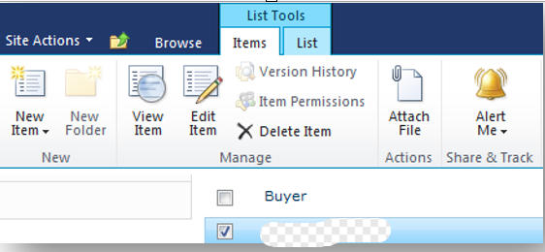
The dialog box below will appear:
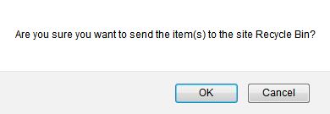
Click OK.
The screen will refresh and the Buyer you selected will be deleted.
You can click Browse tab to reactivate the home page toolbar.
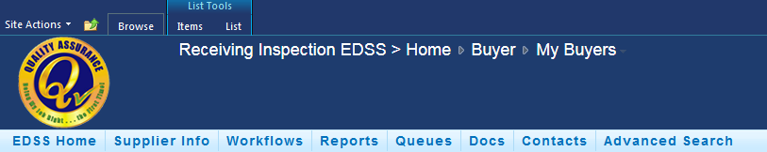
Browse tab

Workflow Submission APPROVED by Lockheed Martin Inspector
If the data is APPROVED, you will be notified via e-mail and no additional effort is required on your part for this submission.

Below is a sample of the email that you should receive upon approval:
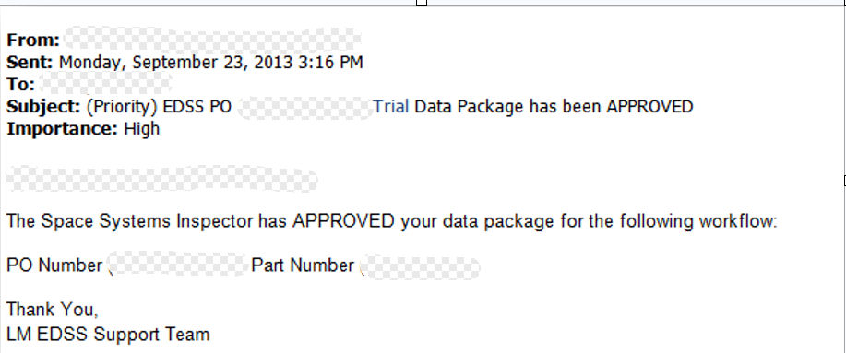

Workflow Submission REJECTED by Lockheed Martin Inspector
If the data is REJECTED, you will also be notified via e-mail but stating that your data has been REJECTED and asking you to view the comments submitted by the Inspector for an explanation of the rejection.
****DO NOT SUBMIT ANOTHER WORKFLOW PACKAGE. THE CORRECTED CERTS MUST BE UPLOADED IN THE ORIGINAL DATA PACKAGE.***
This e-mail will contain a link that will direct you to your Personal Assignment section of EDSS (Personal Assignments Link)
Below is a sample of the email you will receive upon rejection:
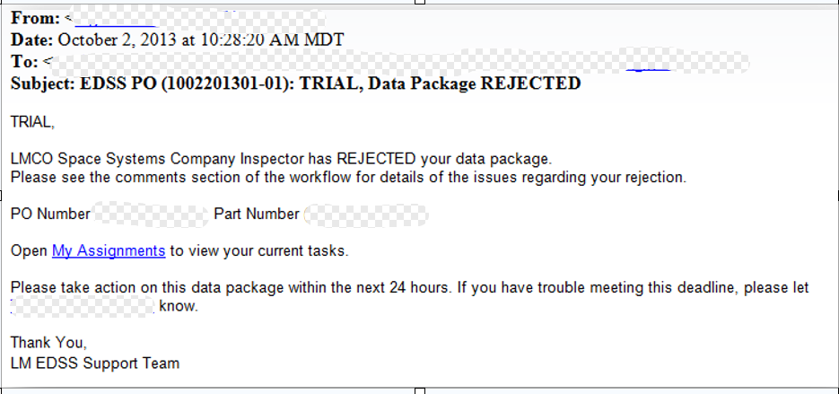
NOTE:
If you are a supplier that has a Communal Mailbox the rejected data packages will be seen there rather than in My Assignments.

Accessing Rejected Submissions My Assignments
If you choose to access rejected submissions via EDSS you will find them in the My Assignments link under the Queues menu if you have that setup for your company.
Follow the steps below to find rejected submissions:
- Choose one of the following:
- Using your browser access the link https://space-us.external.lmco.com/sites/edss/default.aspx

You will then be taken to the main EDSS Page.
(Items that appear on the initial screen may differ depending on user permissions)

- Click Queues to activate the drop down menu.
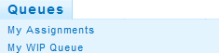
- Choose My Assignments
A screen similar to the one below will appear:
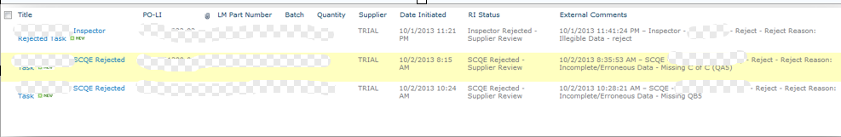
- Click on the Workflow title to open.

A screen similar to the one below will appear:
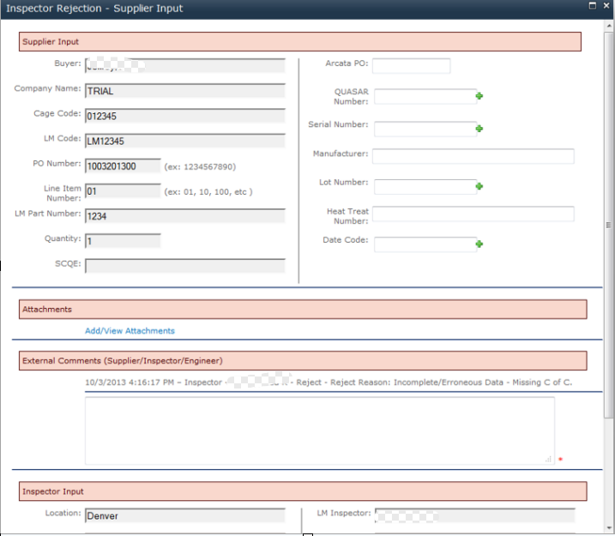
- You can view the external comments for information regarding the rejection reason.
NOTE: For Security reasons you will not be allowed to delete documents from a prior submission. You will be required to submit an additional new/corrected copy of the document(s). You do not need to add a new workflow only add new/updated documents in the current folder.
- You will also see rejection reason if you scroll to the Inspector Input section toward the bottom of the input screen.
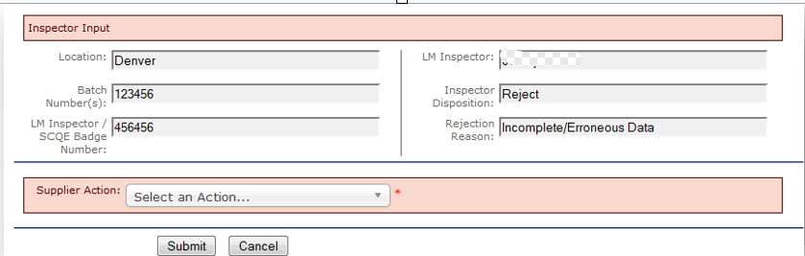
- Make the corrections and then choose the action under the Supplier Action drop down list box.
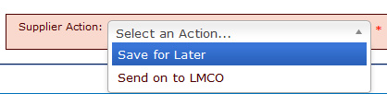
- Choose one of the following:
- Save for Later – allows you to save the workflow to your My Assignments to work again in the near future.
- Send to LMCO – allows you to send the corrected package back to LMCO for approval.

- Click on the button.

The item will be rerouted to the inspector for approval.

Accessing Rejected Submissions Communal Mailbox Assignments
If you choose to access rejected submissions via EDSS you will find them in the Communal Mailbox Assignments link under the Queues menu if you have that setup for your company.
Follow the steps below to find rejected submissions:
- Choose one of the following:
- Using your browser access the link https://space-us.external.lmco.com/sites/edss/default.aspx

You will then be taken to the main EDSS Page.
(Items that appear on the initial screen may differ depending on user permissions)

- Click Queues to activate the drop down menu.
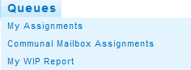
- Choose Communal Mailbox Assignments
A screen similar to the one below will appear:
- Click on the Workflow title to open.

A screen similar to the one below will appear:
- You can view the external comments for information regarding the rejection reason.

NOTE: For Security reasons you will not be allowed to delete documents from a prior submission. You will be required to submit an additional new/corrected copy of the document(s). You do not need to add a new workflow only add new/updated documents in the current folder.

- You will also see rejection reason if you scroll to the Inspector Input section toward the bottom of the input screen.
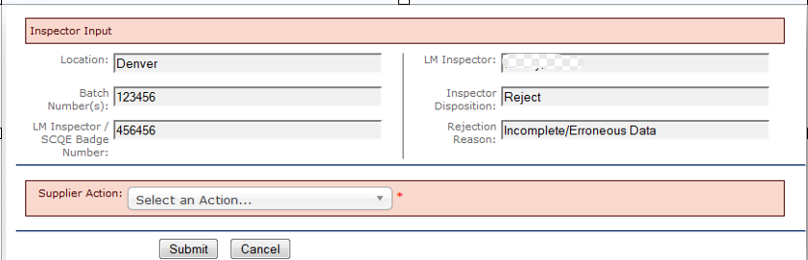
- Make the corrections and then choose the action under the Supplier Action drop down list box.
- Choose one of the following:
- Save for Later – allows you to save the workflow to your My Assignments to work again in the near future.
- Send to LMCO – allows you to send the corrected package back to LMCO for approval.

- Click on the button.

The item will be rerouted to the inspector for approval.

My (Work In Process) WIP Queue
The My WIP queue will allow you to view all of the items that are in process. Looking that the information will also provide you information as to where in the process the item is located.
Follow the steps below to access the My WIP Queue:
- Choose one of the following:
- Using your browser access the link https://space-us.external.lmco.com/sites/edss/default.aspx

You will then be taken to the main EDSS Page.
(Items that appear on the initial screen may differ depending on user permissions)

- Click Queues to activate the drop down menu.
- Choose My WIP Report

The following screen will appear:
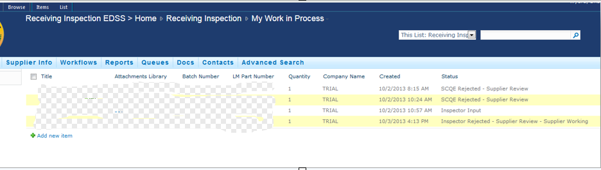
You can click on the Title to open the item and look at the data or even click on the attachment to view the attached documents.
Below is a picture of the item when you click on the Title:
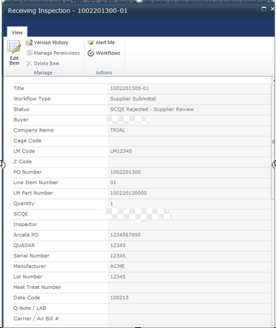
The picture below is a sample of what you see when you click on the Attachments.
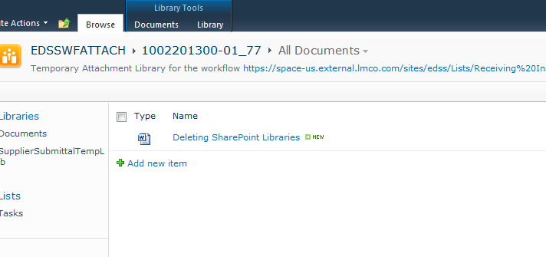

Supplemental Folders - Viewing Information
Once an item has been completed you can view the items by following the steps below:

- Access EDSS by using the URL below:

https://space-us.external.lmco.com/sites/edss/default.aspx
You will see a screen similar to the one below appear:
(Items that appear on the initial screen may differ depending on user permissions)
- Click on Supplier Info to enable the drop down list box and click the collection that appears.
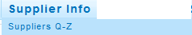
Supplier Site Collections
The Supplier Libraries the Site Collection will appear on the left side navigation.
- Choose the Library to view.

A screen similar to the one below will appear:
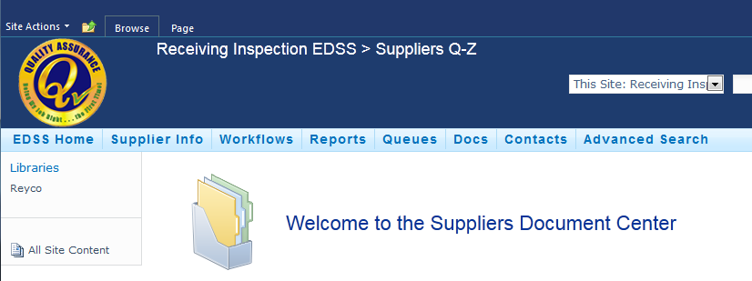
Supplier Library
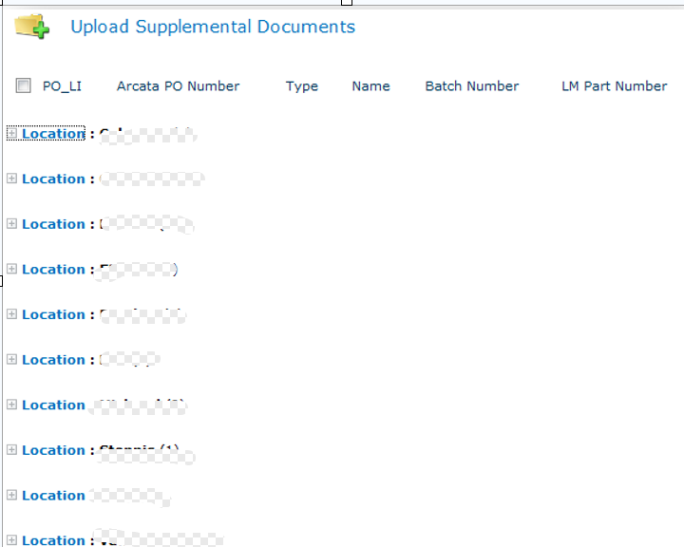
- Click on the + sign located to the left of the Location you want to see.

- Click the + sign located to the left of the Archive Year you want to expand.

The completed items will be listed.
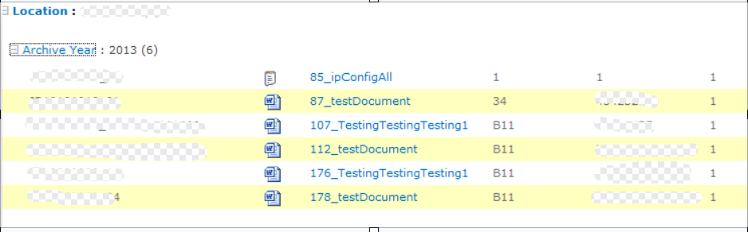
- Click the item you want to view.

Supplemental Folders – Viewing Detail Information
Once an item has been completed you can view the items by following the steps below:

- Access EDSS by using the URL below:

https://space-us.external.lmco.com/sites/edss/default.aspx

You will see a screen similar to the one below appear:
(Items that appear on the initial screen may differ depending on user permissions)
- Click on Supplier Info to enable the drop down list box and click the appropriate Site Collection.

Supplier Site Collection

The Supplier Libraries the Site Collection will appear on the left side navigation.
Supplier Libraries
- Choose the Library to view.

A screen similar to the one below will appear:
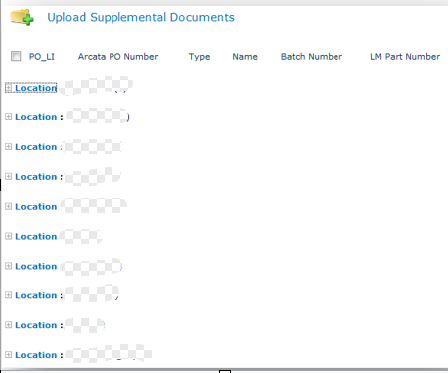
- Click in the white space to the right of the list
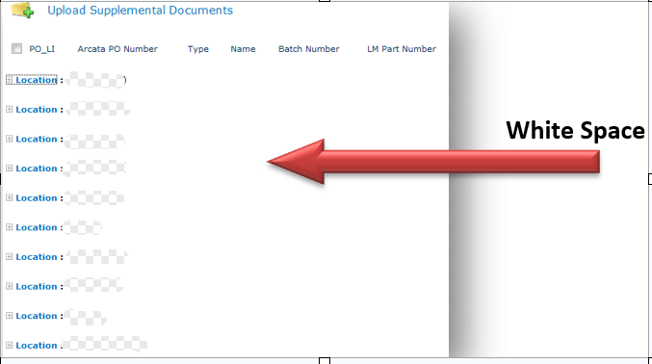

This should activate the Ribbon on the top of the page
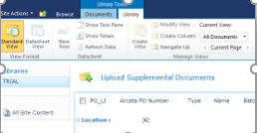

- Click the Library tab.
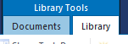
Library Tab
- Locate the Manage Views Group and choose the drop down arrow next to All Documents.
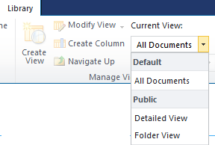
Detailed View
- Click on Detailed View.

The completed items will be listed.

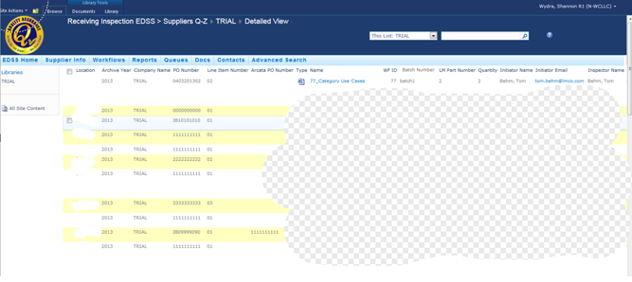

Searching EDSS
The Advanced Search feature allows users to enter multiple search parameters to locate the items they need.

Follow the steps below to use the EDSS Advanced Search:

- Access EDSS by using the URL below:

https://space-us.external.lmco.com/sites/edss/default.aspx

You will see a screen similar to the one below appear:
(Items that appear on the initial screen may differ depending on user permissions)
- Click Advanced Search.
A screen similar to the one below will appear:
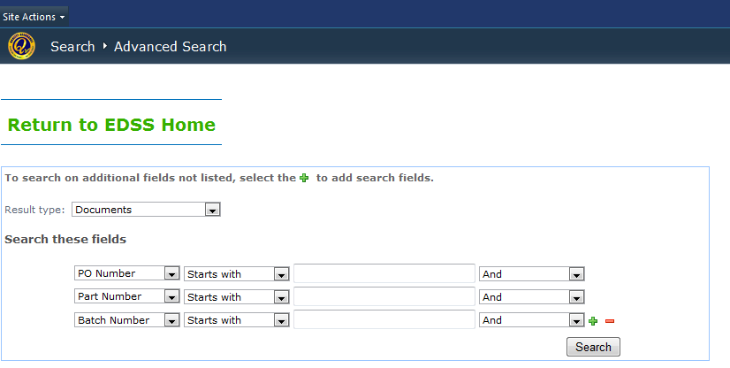
The screen defaults with the three most searched items, however you can choose to add, remove or change the items.

- Choose the Result types you wish to have the search return:
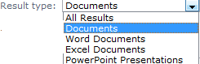
- Click the to add a new search field or to delete a search field.

- Click the first drop down list box to choose a field to search by:
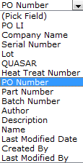
- Click the second field to choose how to search:
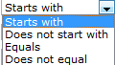
- Enter the value in the third field
- Choose how you want the search to combine the multiple search parameters.
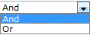
- Click the button.

Items that match the search parameters will return in the search window:
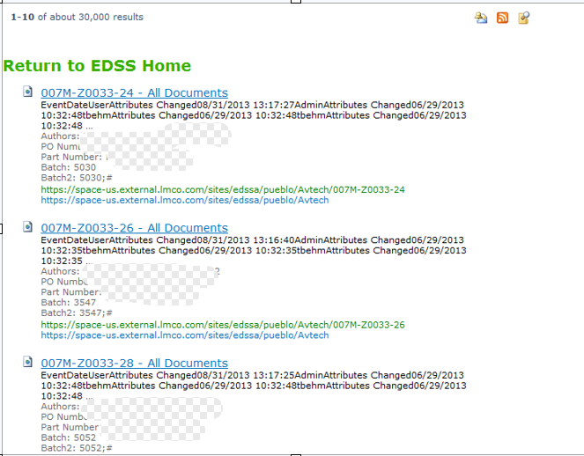
- Choose one of the following:
- Click Return to EDSS Home to return to the home page
- Click an Item to be routed to its location.

Note:
If you click an item and want to return to the search results you must click the Back button on your browser. The picture below is the back button from Internet Explorer.
Back button

